16.Create a Cloning of a VM and Test it by loading the Previous Version/Cloned VM

Step 1:Creating cloning vm by previous version

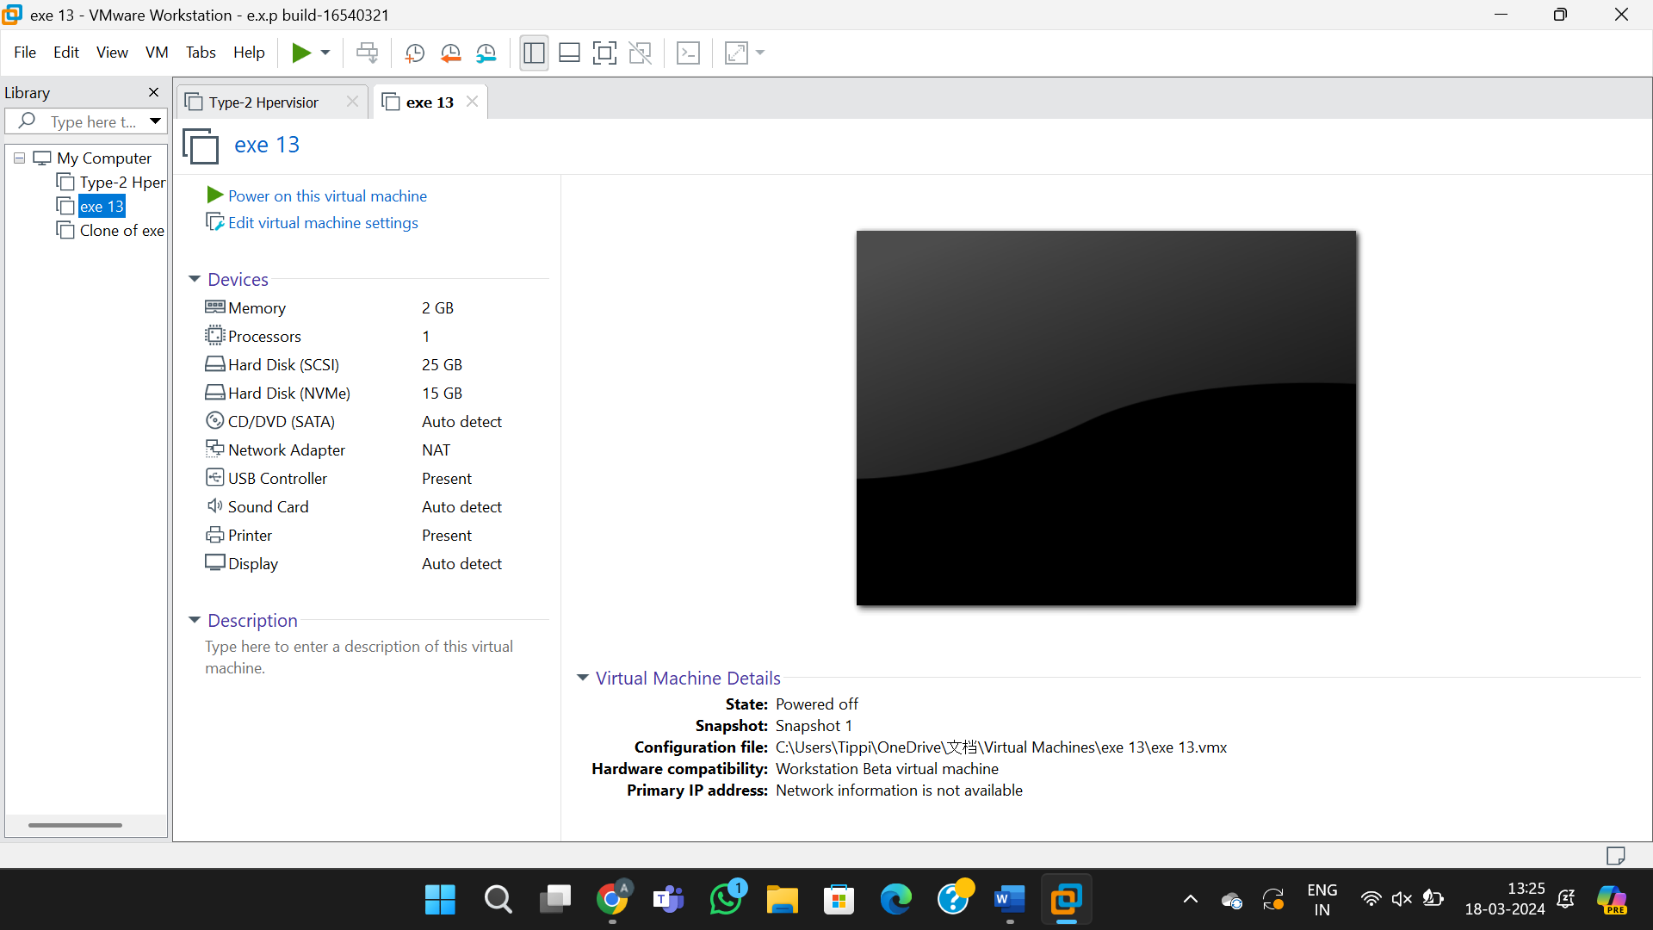

Step 2:Clonned from previous experiment vm ware

